LGA Perceptions Survey 2017/2018: Sector Led Improvement Questions

Purpose of report
For discussion.

Summary
This report provides members with a summary of the responses to the sector led improvement questions in the LGA’s annual perceptions survey of our membership.
The results of the full survey have been reported to the LGA Leadership Board, which oversees this work and the follow-up action plan (which can be found as Appendix A to this paper).

Recommendation
That Members of the Improvement and Innovation Board considers the responses to the sector led improvement questions in the latest perceptions survey and agrees any actions.
Action
As directed by Members.

Contact officer: Juliet Whitworth Kate Cooper
Position: Research and Information Manager Senior Analyst
Phone no: 020 7664 3287 0207 664 3274
Email: Juliet.whitworth@local.gov.uk kate.cooper@local.gov.uk

LGA Perceptions Survey 2017/2018: Sector Led Improvement Questions
Background
- This is the sixth consecutive year the LGA has undertaken a perceptions survey of our membership. This comprehensive, cross-cutting research provides us with a benchmark to inform future work and gives us a good understanding of the current views of member authorities. In addition, it helps us to better understand their views on the benefits of membership, their support needs, sector-led improvement, how well informed they feel about our work and areas for improvement.
- A total of 1,004 interviews were undertaken with a sample of representatives from councils across all the English regions (including chief executives, directors, leaders, chairs of scrutiny, portfolio holders, frontline councillors, and, for the first time in 2017, leaders of the opposition).
- The results of the survey were reported to the LGA Leadership Board on 11 April. The Leadership Board oversees an action plan (which can be found as an annex to this paper) to help support some of the key findings, in particular, work to help improve the overall awareness of the LGA, sector-led improvement and our work amongst frontline councillors.
- The action plan includes actions such as offering to provide feedback to full council/front-line councillors, from peer review work in councils, as well as continuing with initiatives such as free places for frontline councillors at the LGA annual conference, allocated through the group offices.
Summary of results
Views on the LGA
- Overall, the 2017/18 results are positive, and broadly consistent with last year. The results show that respondents have a high level of awareness of the LGA and the work we undertake on their behalf; there are high levels of advocacy (those who would speak positively about the LGA) and satisfaction with the work of the LGA remains high.
- Table 1 and Figure 1 below show how key results have changed since 2012. All of the categories in Table 1 have seen a significant increase since the first wave of the survey in 2012. Most notably, there has been a 19 percentage point increase in the proportion who think that sector-led improvement is the right approach in the current context, and a 16 percentage point increase in the proportion saying that the LGA demonstrates value for money.
Table 1: Summary of positive responses given for key measures

Question | 2012 | 2013 | 2014 | 2015 | 2016 | 2017 | Change from 2016
How well do you know the LGA? | 62% | 72% | 73% | 73% | 75% | 73% | -2
I would speak positively about the LGA | 63% | 73% | 72% | 74% | 74% | 73% | -1
Satisfied with the work of the LGA | 63% | 70% | 75% | 76% | 73% | 73% | 0
The LGA keeps you informed about its work | 69% | 78% | 79% | 84% | 83% | 80% | -3
Sector-led improvement is the right approach in the current context | 59% | 62% | 63% | 71% | 70% | 78% | +8
The LGA demonstrates value for money | 43% | 53% | 53% | 57% | N/A | 59% | +2*
*change from 2015
Figure 1: Summary of positive responses given for key measures

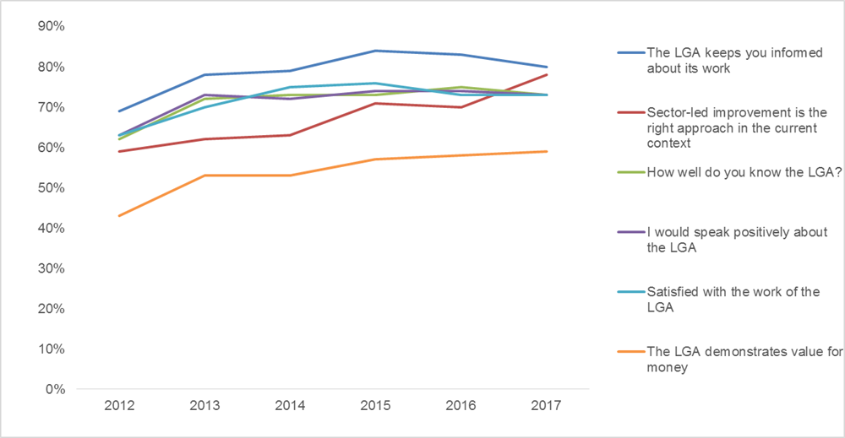

Sector-led improvement
- Respondents were asked to what extent they agree or disagree that sector-led improvement is the right approach in the current context.

  - There was an eight percentage point increase since 2016, in the proportion who said that a sector-led improvement approach is right in the current context (78 per cent). Directors (90 per cent), chief executives (88 per cent) and leaders (86 per cent) are strong drivers of this.

  - Since 2012, there has been a 19 percentage point increase in the proportion saying that sector-led improvement is the right approach.
- Respondents were asked how useful elements of the LGAs improvement support offer are for councils.
  - Access to good practice to help authorities learn from others was seen as the most useful aspect of the LGA’s improvement support offer for councils (87 per cent), followed by peer challenges to provide an external view on performance (83 per cent) and training for councillors (79 per cent).
- Respondents were asked, overall, thinking about the improvement support to what extent they thought that this has had a positive impact on their authority.
  - Overall 87 per cent said that LGA improvement support has had a positive impact on their authority (an increase from 83 per cent in 2016).
  - This increases to 95 per cent among chief executives and 96 per cent among leaders.
- Respondents were asked whether they thought the LGA should continue to provide support in a number of areas. Ongoing support from the LGA is valued in all of the areas outlined in the survey:

  - 93 per cent said the LGA should continue to provide practical support to help councils make efficiency savings, transform services and generate income.

  - 93 per cent said the LGA should continue to provide peer challenge and peer support (up from 90 per cent in 2016).
  - 91 per cent said the LGA should continue to provide training for councillors.
  - 87 per cent said the LGA should continue to provide support for developing a flexible and productive workforce, including training for officers.
  - 79 per cent said the LGA should continue to provide support for economic growth and devolution.
  - 75 per cent said the LGA should continue to provide support for increasing housing supply.
- Finally, respondents were asked what new areas of support they would like to see provided by the LGA:
  - 70 per cent agreed that they would like to see support provided for emergency planning and resilience.

  - 62 per cent agreed that they would like to see specific support for children’s improvement.
Differences by role
- As with previous years there are some variations by role. On the whole, chief executives, directors and leaders have a greater knowledge of and satisfaction with the LGA and more strongly positive views of sector-led improvement compared to frontline councillors. The issue of engaging frontline councillors remains a challenge for us and continues to be addressed in our action plan for the year ahead.
Conclusions
- Overall, this year’s results are positive, and broadly consistent with last year. Respondents have a high level of awareness of the LGA and the work we undertake on their behalf, and satisfaction with the work of the LGA remains high.
- The issue of engaging frontline councillors remains a challenge for us and is addressed in the action plan for the year ahead.
- Our sector-led improvement offer remains well regarded, with an increase in the proportion who think that a sector-led improvement approach is right in the current context, and in the proportion saying that LGA improvement support has had a positive impact on their authority.
Implications for Wales
- There are no implications for Wales.
Financial Implications
- There are no additional financial implications arising from this report.
Appendices
- Appendix A - Perceptions survey 2016/17 - Action plan
Next steps
- The LGA Leadership Board is overseeing next steps.

Changes from previous years are only mentioned in the text if they are statistically significant.

